**Write out the requirements for the project as though you are a client requesting a program be written that performs to the tasks specified. The document should be an overall description of the behavior of your program, without technical details.**

**High Level Requirements**

We need to create a web interface where users can have a conversation with a ChatGPT/virtual AI, connect to Spotify, chat with friends, and other features onto a personalized dashboard. For guests, they have limited access to the virtual AI, and are able to play music but will not have the recommended feature, and will not be able to chat with friends.

# Login Page

* Username/Password fields
* ‘Use as Guest’ function

Sign-Up Page

* Set up unique Username/Password fields
  + Out of Scope: creating personalized avatar for GPT AI

# User Dashboard

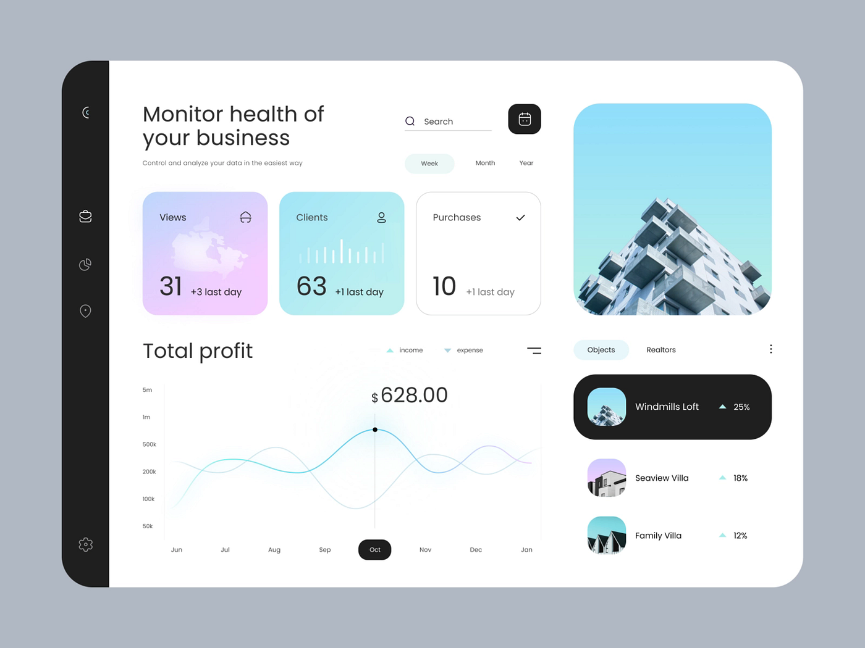

**Signed-up user**:

* GPT module
  + Customized avatar for GPT AI
  + See past conversations with AI
  + Past conversation stored
  + ‘Friends’ feature/chatting (multi-threading feature)
* Spotify module
  + Recommended and played songs from virtual AI (connected to Spotify)
* Calendar
* Weather
* To do list (optional)
* Daily quotes (optional)
* Search in google (optional)

**Guest**:

* GPT module
  + Generic GPT AI without avatar
  + Limited number of conversation requests
  + Unable to play music with Spotify
  + No past conversation stored

# About Us

* Information about our development team, mission, and values
* Testimonials or reviews from satisfied users (optional)
* Links to social media profiles and other relevant platforms (optional)

# Account Management

* Display username
* Allow users to reset their password.
* Connect with Spotify
* ChatGPT/virtual AI function